PACO
PUMPS

Job Name :
Customer :
PO Number :
KP ROTATION VERIFICATION

Discharge
Discharge
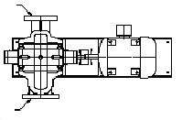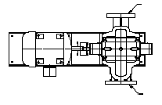
Suction
Suction

Plan View Plan View
Counterclockwise (CCW) Clockwise (CW)

PACO horizontal split case pumps can be configured for either the clockwise (CW) or counterclockwise (CCW) operation. The direction of rotation impacts the location of the suction and discharge connections in relation to the motor. Rotation must be verified prior to release of the order to manufacturing.

Proper identification of rotation in the submittal stage of a project minimizes the risk of cost and time associated with correcting rotation in the field.

To verify rotation direction, please refer to the drawings above, noting suction and discharge locations relative to the motor, and verify against design plans.

Pump Tag | Model | Clockwise (CW) | Counter-clockwise (CCW)
 |  | ☐ | ☐
 |  | ☐ | ☐
 |  | ☐ | ☐
 |  | ☐ | ☐
 |  | ☐ | ☐
 |  | ☐ | ☐

Please contact your PACO Representative if you need assistance in determining rotation.

